**ShopNest Analysis using Power BI**

**INTRODUCTION:**

This report offers an in-depth look at the performance of the Shop Nest Store, using a Power BI dashboard to highlight important metrics and trends. The dashboard showcases insights related to sales, customer behaviour, product performance, and order fulfilment.

**Top 10 Product Categories**

Question 1: What are the top 10 best-selling product categories in ShopNest Store?

Answer-The bar chart displays the top 10 product categories based on sales volume. "Beleza Saude" stands out as the leading category, with "Casa Mesa Banho" and "Informática Acessórios" following closely behind. This data is essential for identifying which product lines generate the highest revenue, aiding in inventory management and marketing strategies.

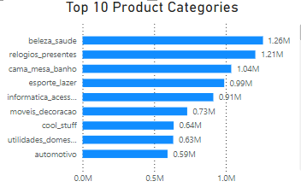

**2. Delayed Order Analysis**

The chart titled "Delayed Order Analysis" illustrates the number of delayed orders across various product categories. The data shows that " Casa Mesa Banho " has the highest count of delayed orders, followed by "Esportes" and "Informatica."

Key Observations: " Casa Mesa Banho " is clearly the category with the most delayed orders, highlighting a potential area for improvement in the order fulfillment process for this category.

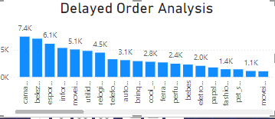

**3.Payment Method Analysis**

The pie chart titled "Payment Method Analysis" shows the distribution of payment methods used by customers in the ShopNest Store. 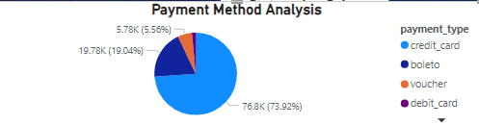

Key Observations:

**Credit Card Dominance:** Credit card payments make up the largest portion of transactions, totaling around 76.8K (77.75K) out of the overall count.

**Boleto Payments**: Boleto transactions represent the second-largest category, accounting for about 19.8K (18.73K).

**Other Payment Methods**: The other payment options, such as debit cards and potentially others not detailed here, contribute a smaller fraction to the total.

**4-Product Rating Analysis:**

**Key Insights: Top 10 Highest -Rated Products**

* The top 10 highest-rated products have average review scores ranging from 4.67 to 4.14, indicating a high level of customer satisfaction overall.
* The chart provides a visual representation of product performance based on customer ratings, allowing for quick identification of top-performing products.

Here are some short insights based on the "Below 10 Lowest-Rated Products" bar chart:

**Key Insights: Below 10 lowest -Rated Products**

* **"Seguranca"** has the lowest average review score, followed by "Papelaria" and "Portateis."
* The lowest-rated products have average review scores ranging from 3.13 to 4.04, indicating a range of customer satisfaction levels.
* The chart provides a visual representation of product performance based on customer ratings, highlighting areas for improvement.

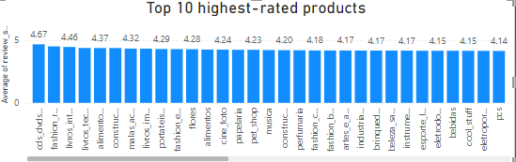

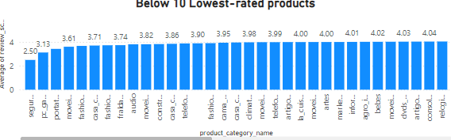

**5-** **Seasonal Sales Patterns chart -**

**Key Insights:**

Overall Revenue Trend: Total revenue has been on a downward trend from 2016 to 2018. 2017 Peak: The revenue reached its highest point in 2017, particularly in the second quarter. Seasonal Fluctuations: Sales show some seasonal patterns, with lower revenue typically seen in the first and fourth quarters each year. 2018 Decline: Revenue in 2018 dropped significantly compared to 2017, especially in the fourth quarter.

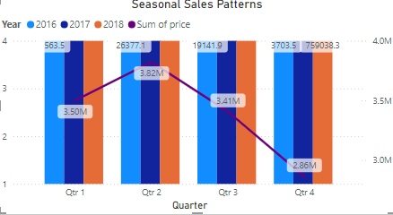

**6-State-wise Sales Analysis**

Insights from the bar chart titled "State-wise Sales Analysis":

Sales are heavily concentrated in a few states, with SP, RJ, and MG leading the way. Many states show low sales figures, indicating a long-tail distribution. Some states, such as CE and OM, stand out as outliers and warrant further investigation.

This summary highlights the main points: Uneven distribution: Sales are not evenly spread across states.

Top performers: SP, RJ, and MG are the sales leaders.

Long tail: Numerous states report low sales.

Outliers: CE and PE exhibit particularly low sales.

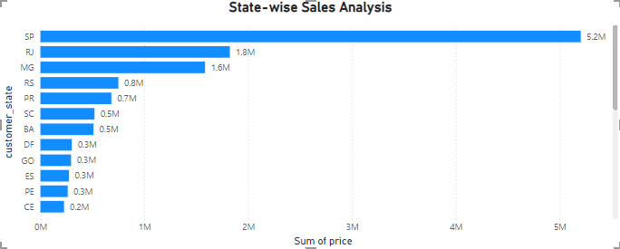

**7-Revenue Analysis-**

Insights from the "Revenue Analysis" Chart:

Steady Increase: The chart shows a steady rise in revenue from 2017 to 2018.

Major Surge in 2017: There was a significant increase in revenue from 2017 to 2018.

Slower Growth in 2016: Although revenue grew in 2016 compared to 2017, the growth rate seems to have slower.

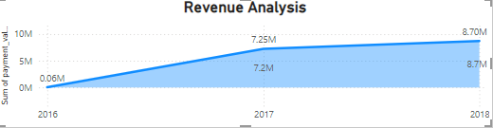

**Conclusion-**

The ShopNest Store Analysis Dashboard offers a detailed look at the store's performance. With the insights obtained from this dashboard, the store can make well-informed decisions to enhance operations, boost customer satisfaction, and increase revenue.